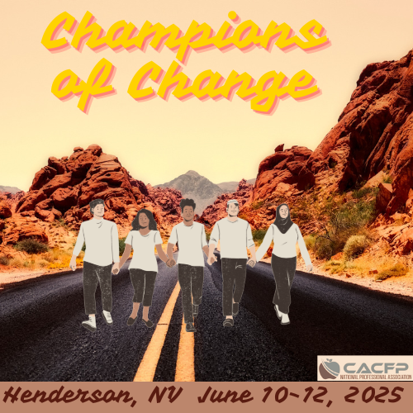
CALL FOR PANELISTS

The 2025 Child and Adult Care Food Program (CACFP) National Processional Association (NPA) Conference is starting to take shape and will be held June 10-12, 2025, at the Sunset Station in Henderson, NV.

A few conference sessions have been planned as USDA-State Agency Panel Discussions to highlight best practices in administering the CACFP. State agency staff can share resources, learn how the CACFP is administered in other states, and make connection with CACFP professionals in other state agencies.

NPA is looking for panelists to participate in one or more State Agency Panel Discussion and we are hoping you or a member of your staff will be willing to participate and share best practices your state agency has to offer.

Below are the USDA-State Agency Panel Discussion topics:

Audit Fund Utilization: What creative solutions has your state agency developed to meet the new review requirements with limited audit funds? For example, contracting out the additional reviews.

Serious Deficiency Process: How is your state agency planning for the revisions to the serious deficiency process outlined in the purposed rule?

Each presenter should plan on 10-15 minutes of presenting with additional time for questions. If you are interested, or have a staff member that is interested, please have them complete the “Session Panelist Information” form and email the completed form to Lindsay Talbot at ltalbot@agri.nv.gov no later than April 2, 2025. If you have any questions, please either email or call Lindsay at 702-688-4582.

Making connections and sharing resources with your fellow CACFP colleagues is what makes the NPA and the CACFP successful.

SESSION PANELIST INFORMATION

Panelist Name: First and Last Name

Panelist State Agency: State Agency Name

State Agency Address: Street Address, City, State, Zip Code

Panelist Contact Information: E-mail Address Phone: (XXX) XXX-XXXX

Please select from the topics below which panel(s) you would like to participate on:

☐ Audit Fund Utilization:

☐ Serious Management Problems/Serious Deficiency Process:

Your participation and sharing of knowledge and experience is what will make the 2025 CACFP NPA Conference successful.

Please complete and submit this form by no later than April 2, 2025, via email to Lindsay Talbot at ltalbot@agri.nv.gov. If you have any questions, please contact Lindsay by email or phone at 702-668-4582.

Thank you!

